**name = "Rob"**

**steps = 12**

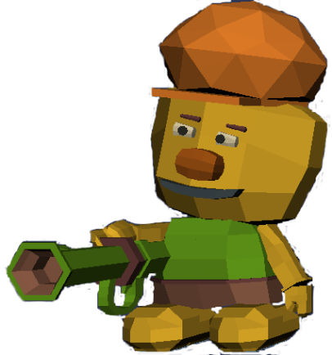

Robs fight against

forgetfulness

I am sure you know the lowercase letters (x, y, z) from math class. The so-called placeholders (or variables) are written instead of numbers. The value of these variables can also change they does not remain constant. This is very similar in computer science. A variable can store any value (numbers, characters, words or even whole sentences). The name of the variable remains, but the value can change at any time.

Rob the Robot needs also variables. With these variables he can remember certain information, such as his name or the number of steps he has already taken.

**Imagine …**

Rob wants to take different measurements on a foreign planet. However, he can only make a total of 10 steps in any direction before recharging his battery. Charing the battery will then take a few hours and means he needs to get enough sunlight. So, he has to device these steps well.

Each variable consists out of three parts:

* **name**: What is the variables name?
* **data type**: What is stored in the variable? A number? A letter? A word?
* **value**: What is the variables content?

number steps = 10

**value**

**name**

**data type**

**Can you complete the missing data for Rob so he can arrive his destination?**

steps = 7  
robot.Left()  
steps = 6  
robot.Left()  
steps = ___  
robot.Left()  
_______ = ____  
robot.Left()  
______________  
robot.Down()  
______________  
robot.Down()  
______________  
print("Rob has " + _______ + " steps left")

